# Answers to Questions from TT 6.1

Name: Jayden Kong

Student ID: 104547242

**Hand execution using a trace table**

*Demonstrate how the following code is executed in the computer.*

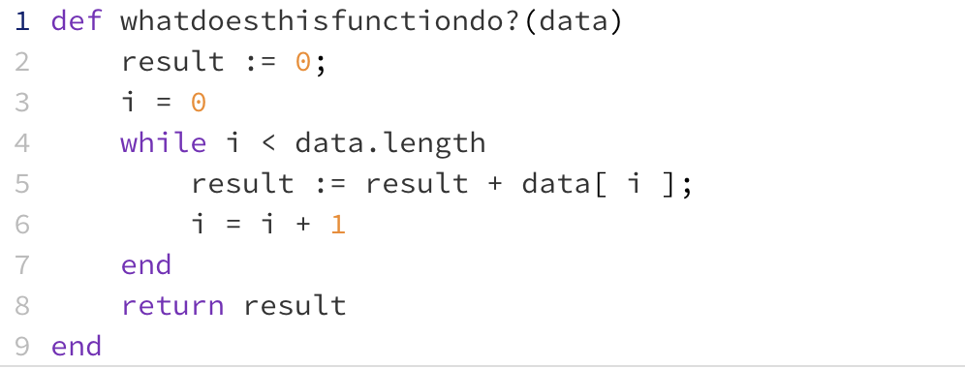

Draw and complete a trace table for the following two sets of data and place the final result in the table below:



**Once you have completed your trace tables (below) write the name you chose for the function above:**

Sum_of_data_set

**Place your trace tables below:**

For data set: [6, -3, 3, 8, 1]

|  |  |  |
| --- | --- | --- |
| Data[i] | i | Result |
| 6 | 0 | 6 |
| -3 | 1 | 3 |
| 3 | 2 | 6 |
| 8 | 3 | 14 |
| 1 | 4 | 15 |

For data set [2, 6, -2, 3]

|  |  |  |
| --- | --- | --- |
| Data[i] | i | Result |
| 2 | 0 | 2 |
| 6 | 1 | 8 |
| -2 | 2 | 6 |
| 3 | 3 | 9 |